STORY GRAMMAR, PAGE 1 MAKE PICTURES FOR YOUR OWN STORY HERE:

CHARACTER (WHO?)

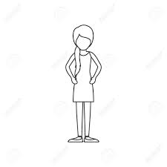

SETTING (WHERE and WHEN)

STORY GRAMMAR, PAGE 2 MAKE PICTURES FOR YOUR
OWN STORY HERE:

FEELING (What does the character feel?)

PLAN

STORY GRAMMAR, PAGE 3 MAKE PICTURES FOR YOUR OWN STORY HERE:

KICK-OFF

ACTIONS and SEQUENCE OF EVENTS (What happens?)

STORY GRAMMAR, PAGE 4 MAKE PICTURES FOR YOUR
OWN STORY HERE:

TIE-UP (What solves the problem?)

CONCLUSION

